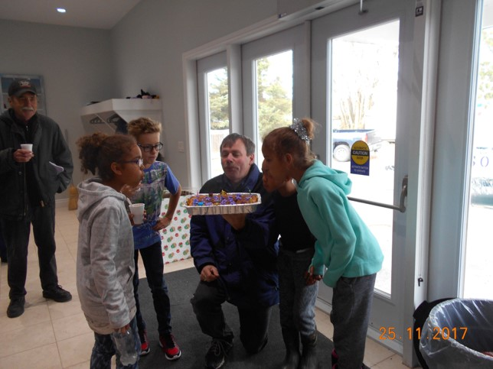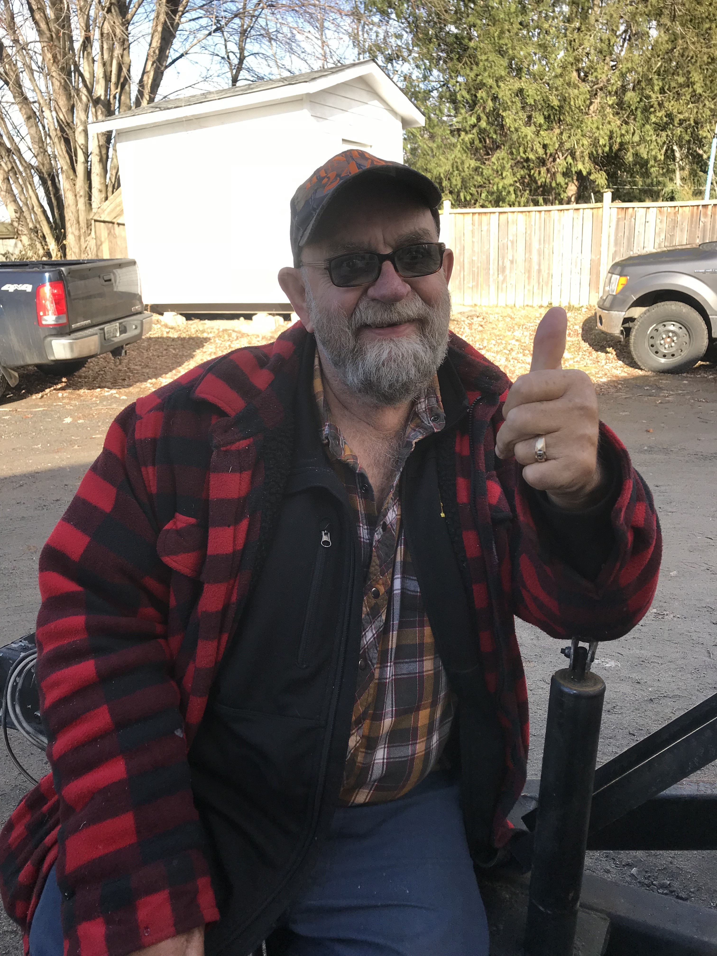

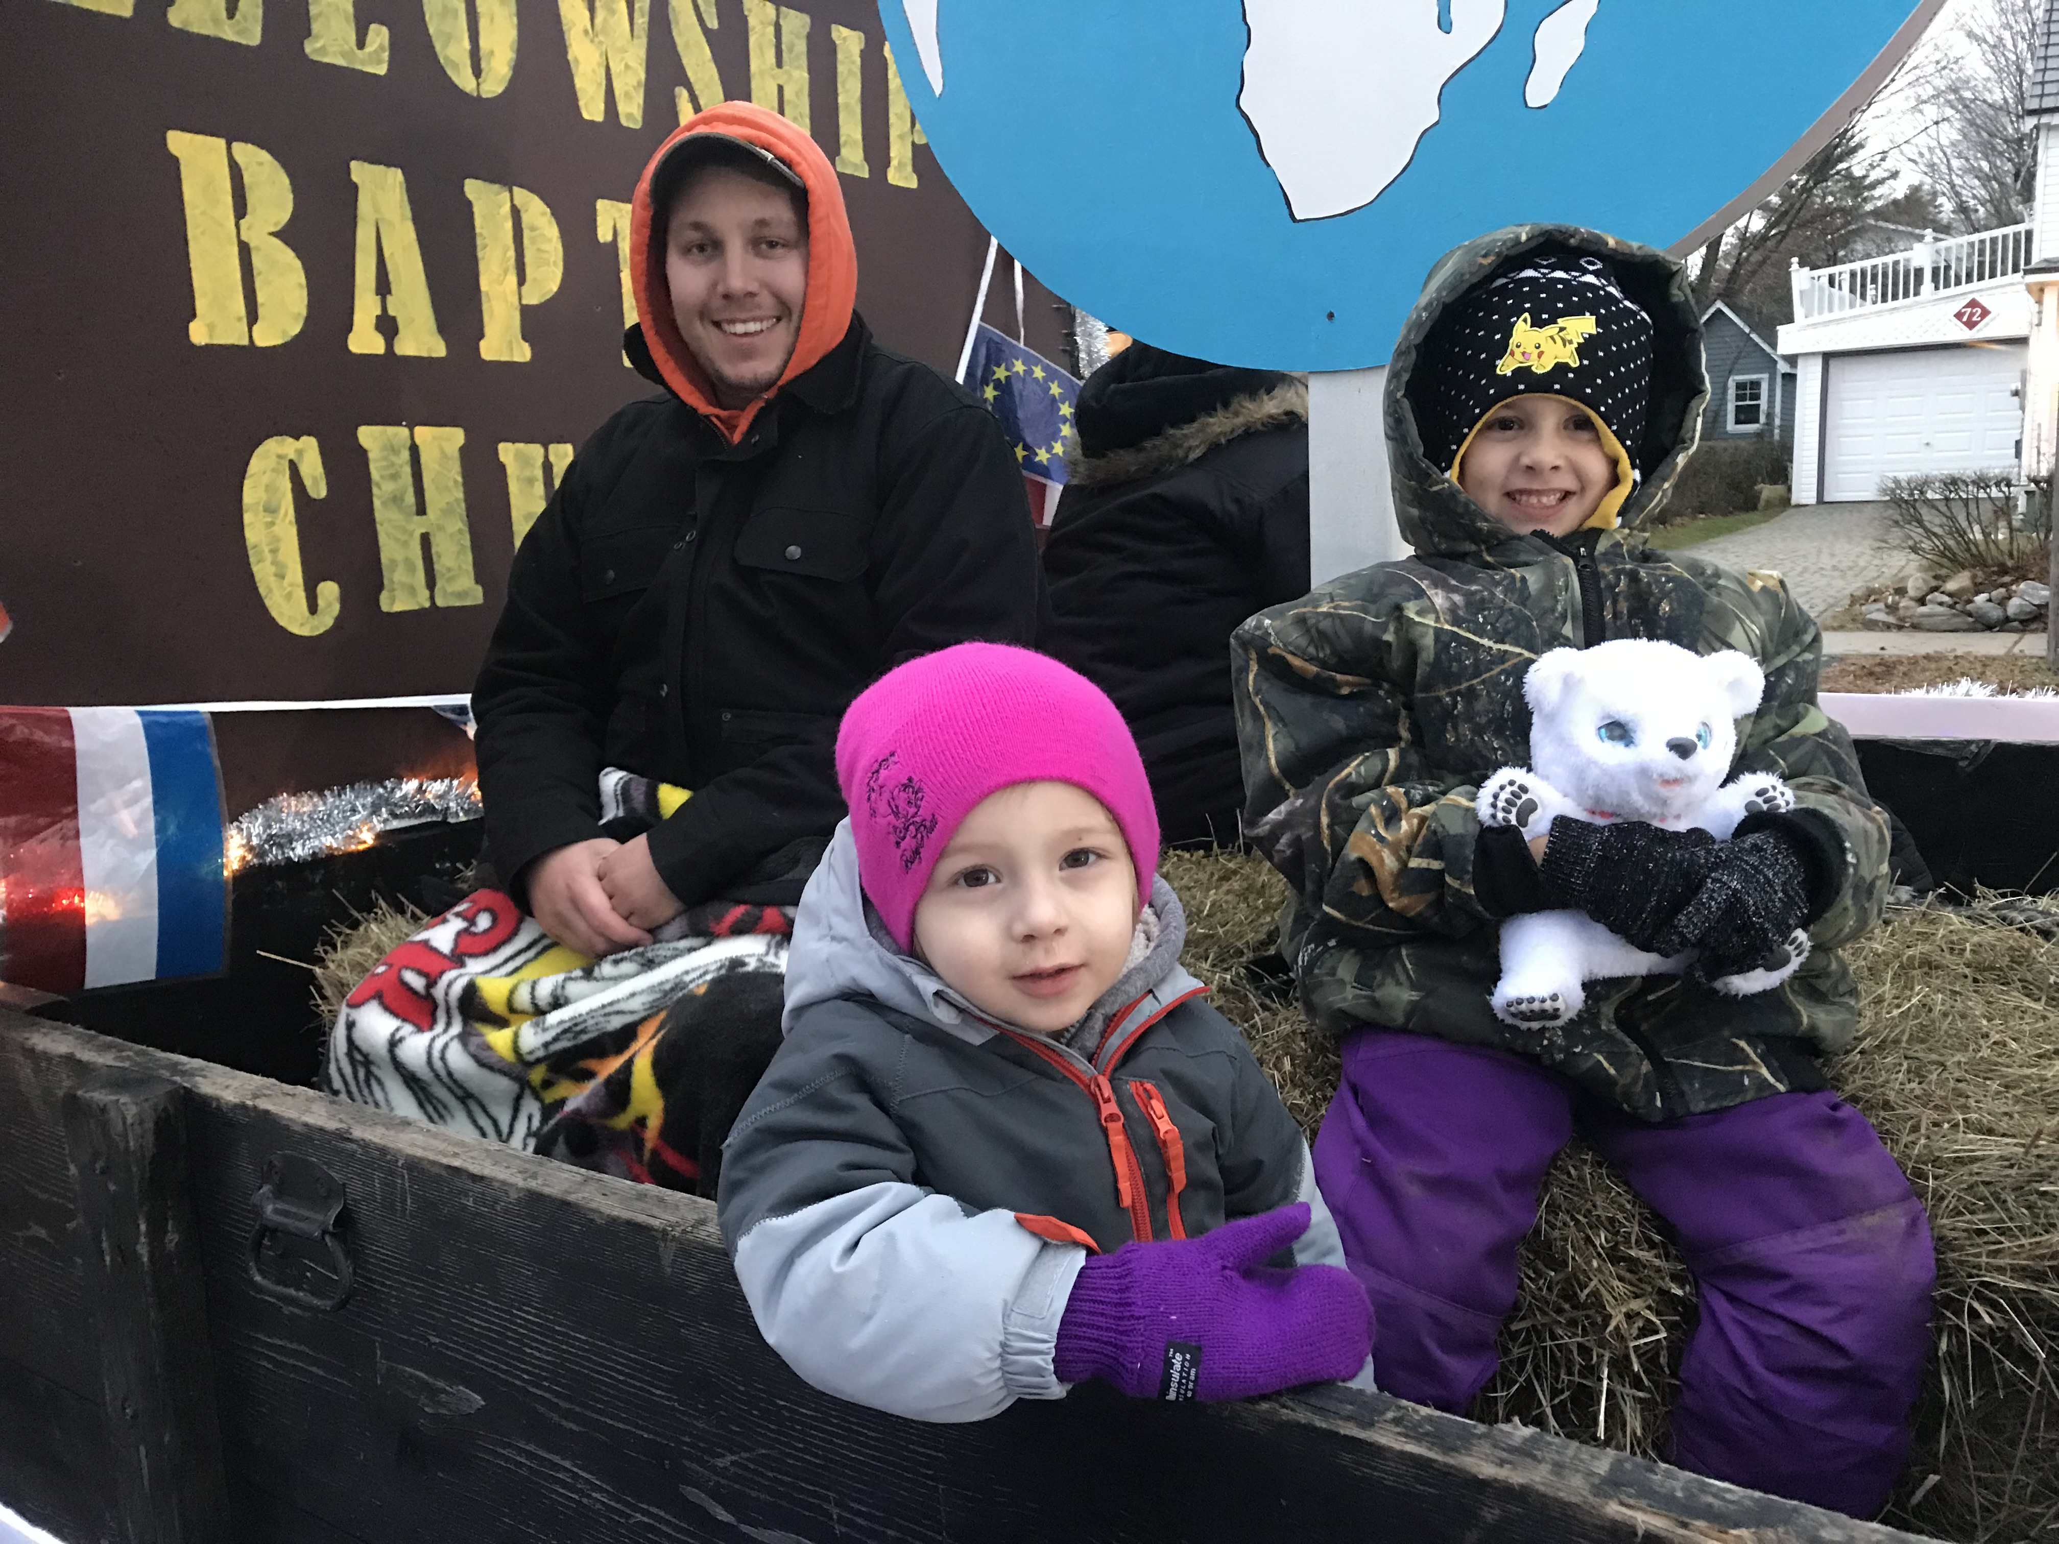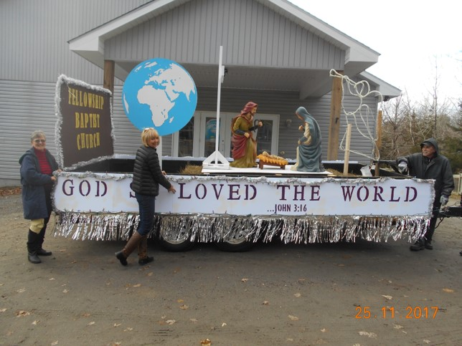

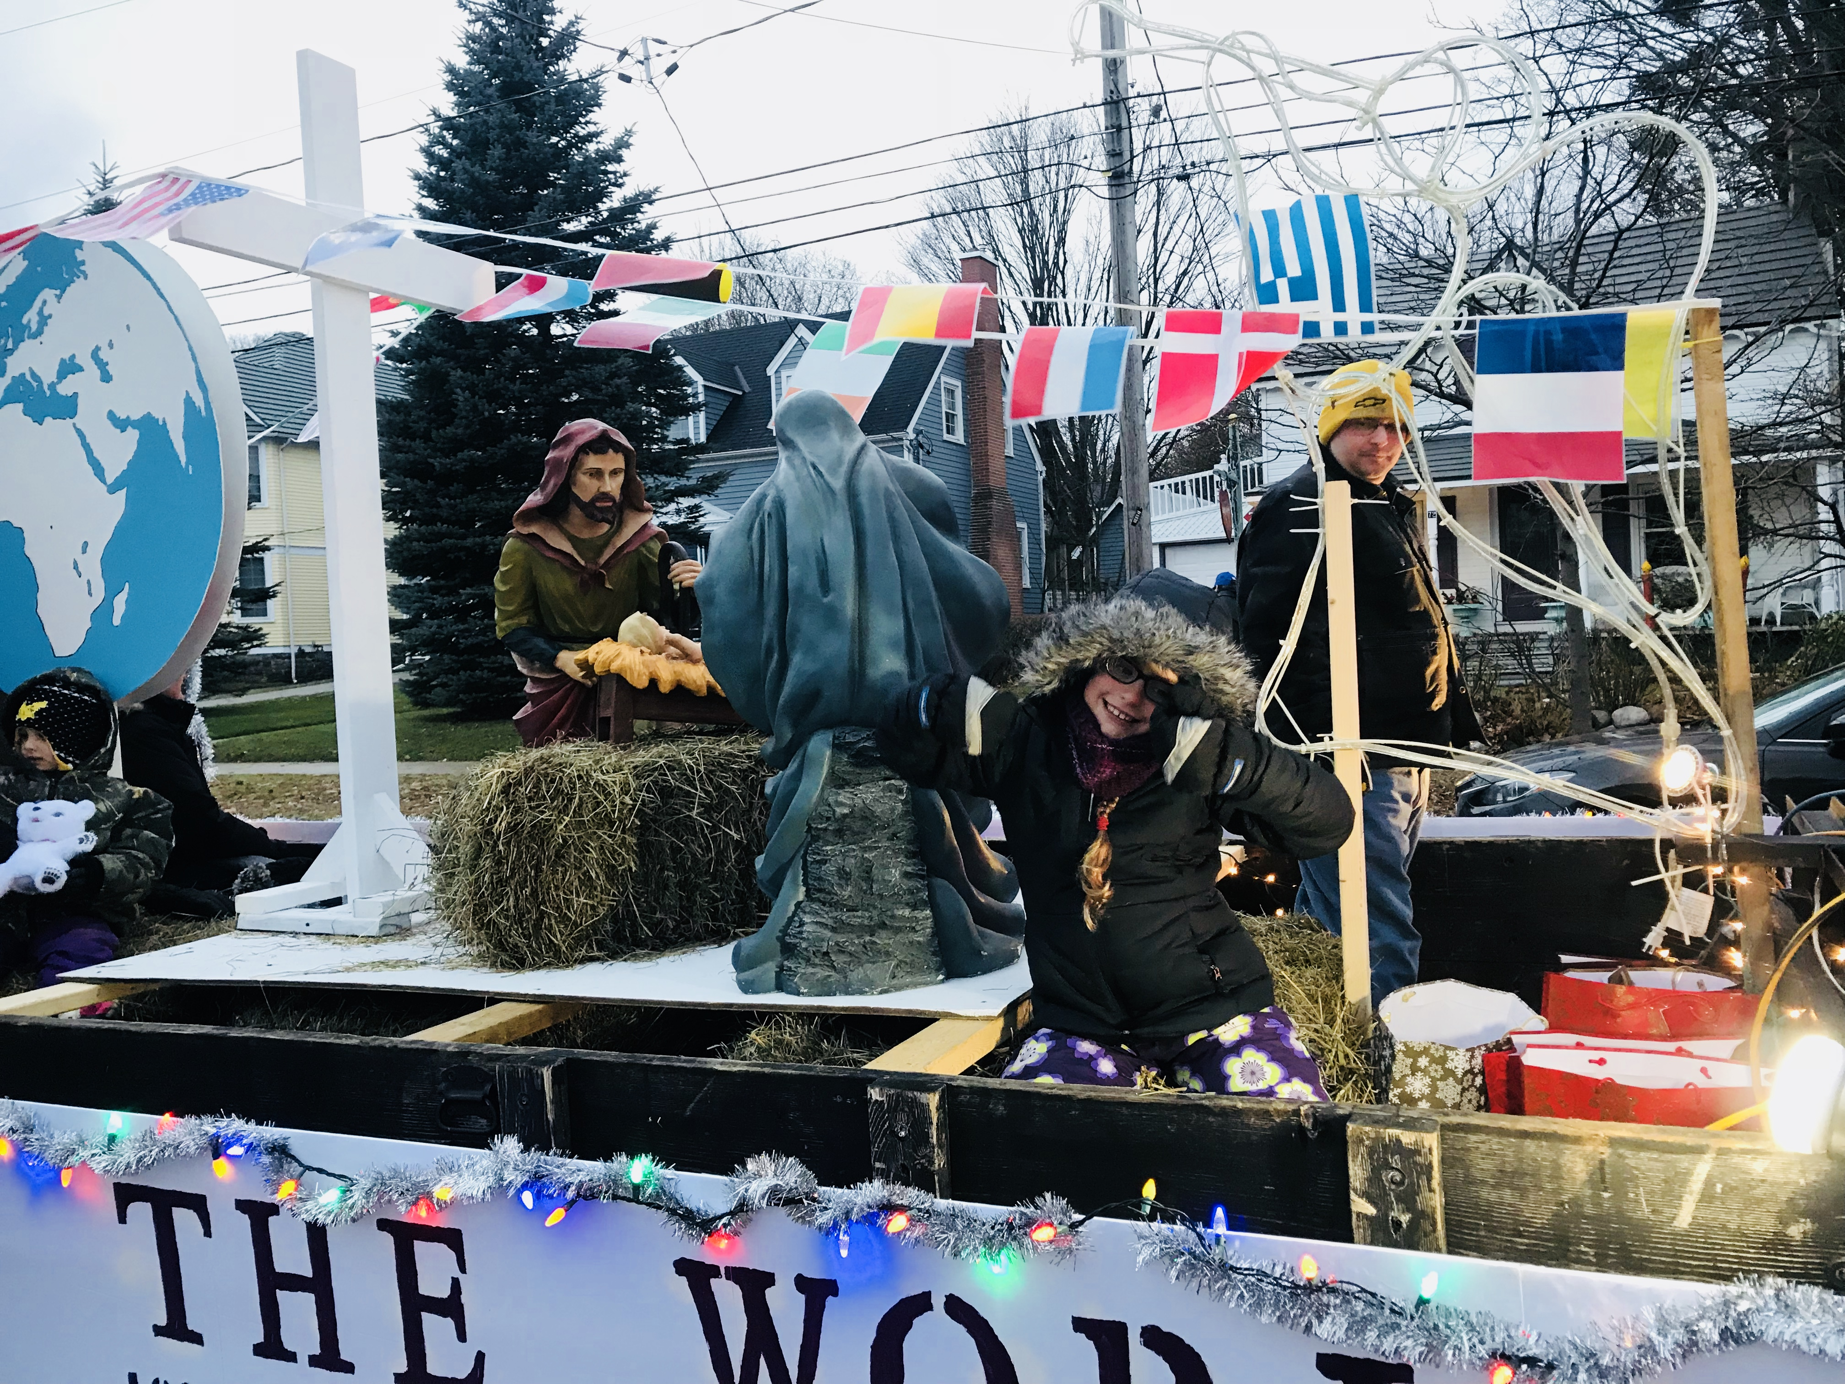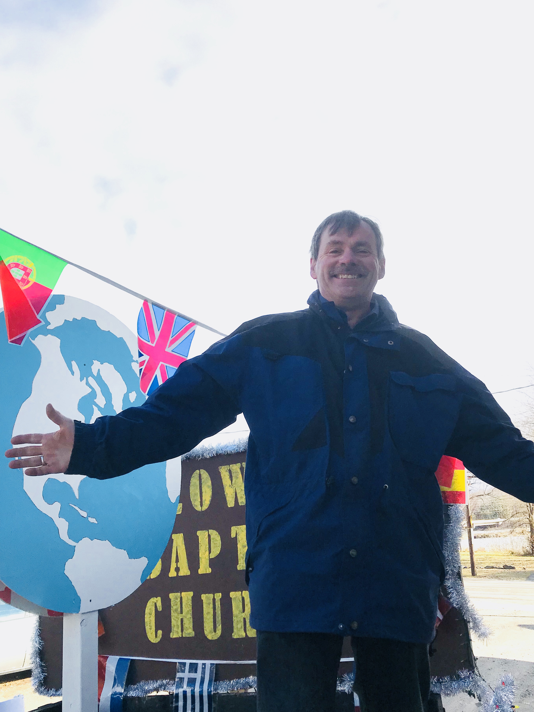
_______________________________________________________________________
Please email Phebe at phebenian@gmail.com or contact Pastor Rick or one of the Deacons if you have any Prayer or Praise items or updates for the bulletin.
Pastor Rick Crockford Home: 705-746-9893
Fellowship Baptist Church
138 William Street, Parry Sound, ON, P2A 1W2
(705) 746-5154
fbc@vianet.ca www.fbcparrysound.com
FELLOWSHIP
BAPTIST CHURCH

Founded on the Rock:
Preaching the Gospel truth; Equipping for Life
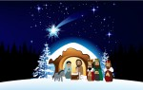

Now may the God of patience and comfort grant you to be like-minded toward one another, according to Christ Jesus, that you may with one mind and one mouth glorify the God and Father of our Lord Jesus Christ.
Romans 15:5,6

Welcome!
December 3, 2017

FELLOWSHIP BAPTIST CHURCH

Welcome To:

9:30 Adult Bible Class – the book of Revelation.
TODAY’S SERVICES
December 3rd, 2017

10:50-11:00 Quiet Meditation to prepare our hearts for worship
Welcome and Prayer
Call to Worship: Psalm 84:5-7
Hymn: #225 Come Christians Join To Sing
Hymn: You Are My King
Hymn: #9 Glorify Thy Name, #10 Majesty
Memory Verse of the Month: Colossians 3:23,24
And whatever you do, do it heartily, as to the Lord and not to men, knowing that from the Lord you will receive the reward f the inheritance; for you serve the Lord Christ.

Announcements
Scripture Reading: Galatians 5:16-26
Video Song: Thrive (Casting Crowns)
Hymn: #270 Joy To The World
Children’s Song: #277 Hark! The Herald Angels Sing
Children’s Story and Dismissal to Junior Church
Sermon- Pastor Rick:
“Walking In The Spirit”
Hymn: #302 Lamb Of God
Communion
Tonight: Power Time Prayer Chapel 6pm,
Eve. Service 6:30pm

THIS WEEK AT FELLOWSHIP:
MONDAY | 10 am  6 pm | Ladies Bible Study  AWANA
TUESDAY
WEDNESDAY | 8:30am  7:30pm | Men’s Breakfast at Trappers  Men’s Bible Study at FBC
THURSDAY | 7 pm | Music Practice
FRIDAY
SATURDAY
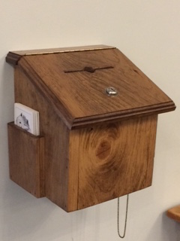
Thank you for your weekly tithes and offerings in the box at the back. “So let each one give as he purposes in his heart, not grudgingly or of necessity; for God loves a cheerful giver.”
2 Corinthians 9:7
Questions/suggestions also welcome.
Christmas Concert-Dec.17, 11am, please let Jenny know what Christmas song, story, or skit, or reading you would like to do
Christmas Caroling Dec 17, 4:50pm Bellvedere Care Centre
New Year’s Eve – fun at the church 8pm-1am
PRAYER
Pray for Tricia McEwen, going through some personal struggles.
Praise for the AWANA program! Please continue to pray for health those in our congregation, and for the salvation of any who haven’t yet accepted Jesus as their personal Saviour. If you have questions about your need for salvation from sin and hell, and what Jesus is offering you, please speak to any of the leadership and we would be happy to help you.
Pray for our Missionaries!
Thorntons –praise for children saved at camp
Lees –for Grassy Narrows people for salvation and for help re: mercury toxicity, addictions, poverty
Midigos –in Goma, DRC, need support for food and small business programs for women. Pray for safety and for peace, and for solution for the spread of cholera in Goma and famine throughout DRC.
Butlers ––PNG, mission work, safety on the rivers. Back at work in PNG doing technical support for inland missionaries.
Brandons –safety in travel, for local pastors receiving training to apply it and see spread of the gospel with locals in Cameroon and the Philippines

