Vision Statement: To see a world where every person comes to know the Lord Jesus as their personal Saviour.

Mission Statement: To be a soul-winning group of believers, founded on Jesus Christ. To live as lights in our community, showing love and equipping believers for a life of serving Christ.
Thank you for your weekly tithes and offerings in the box at the back. “So let each one give as he purposes in his heart, not grudgingly or of necessity; for God loves a cheerful giver.”
2 Corinthians 9:7
Questions/suggestions also welcome.
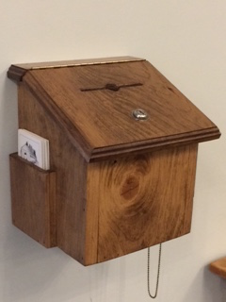
SERMON NOTES

_______________________________________________________________________
Please email Phebe at phebenian@gmail.com or contact Pastor Rick or one of the Deacons if you have any Prayer or Praise items or updates for the bulletin.
Pastor Rick Crockford Home: 705-746-9893
Fellowship Baptist Church
138 William Street, Parry Sound, ON, P2A 1W2
(705) 746-5154
fbc@vianet.ca www.fbcparrysound.com
FELLOWSHIP
BAPTIST CHURCH

Founded on the Rock:
Preaching the Gospel truth; Equipping for Life
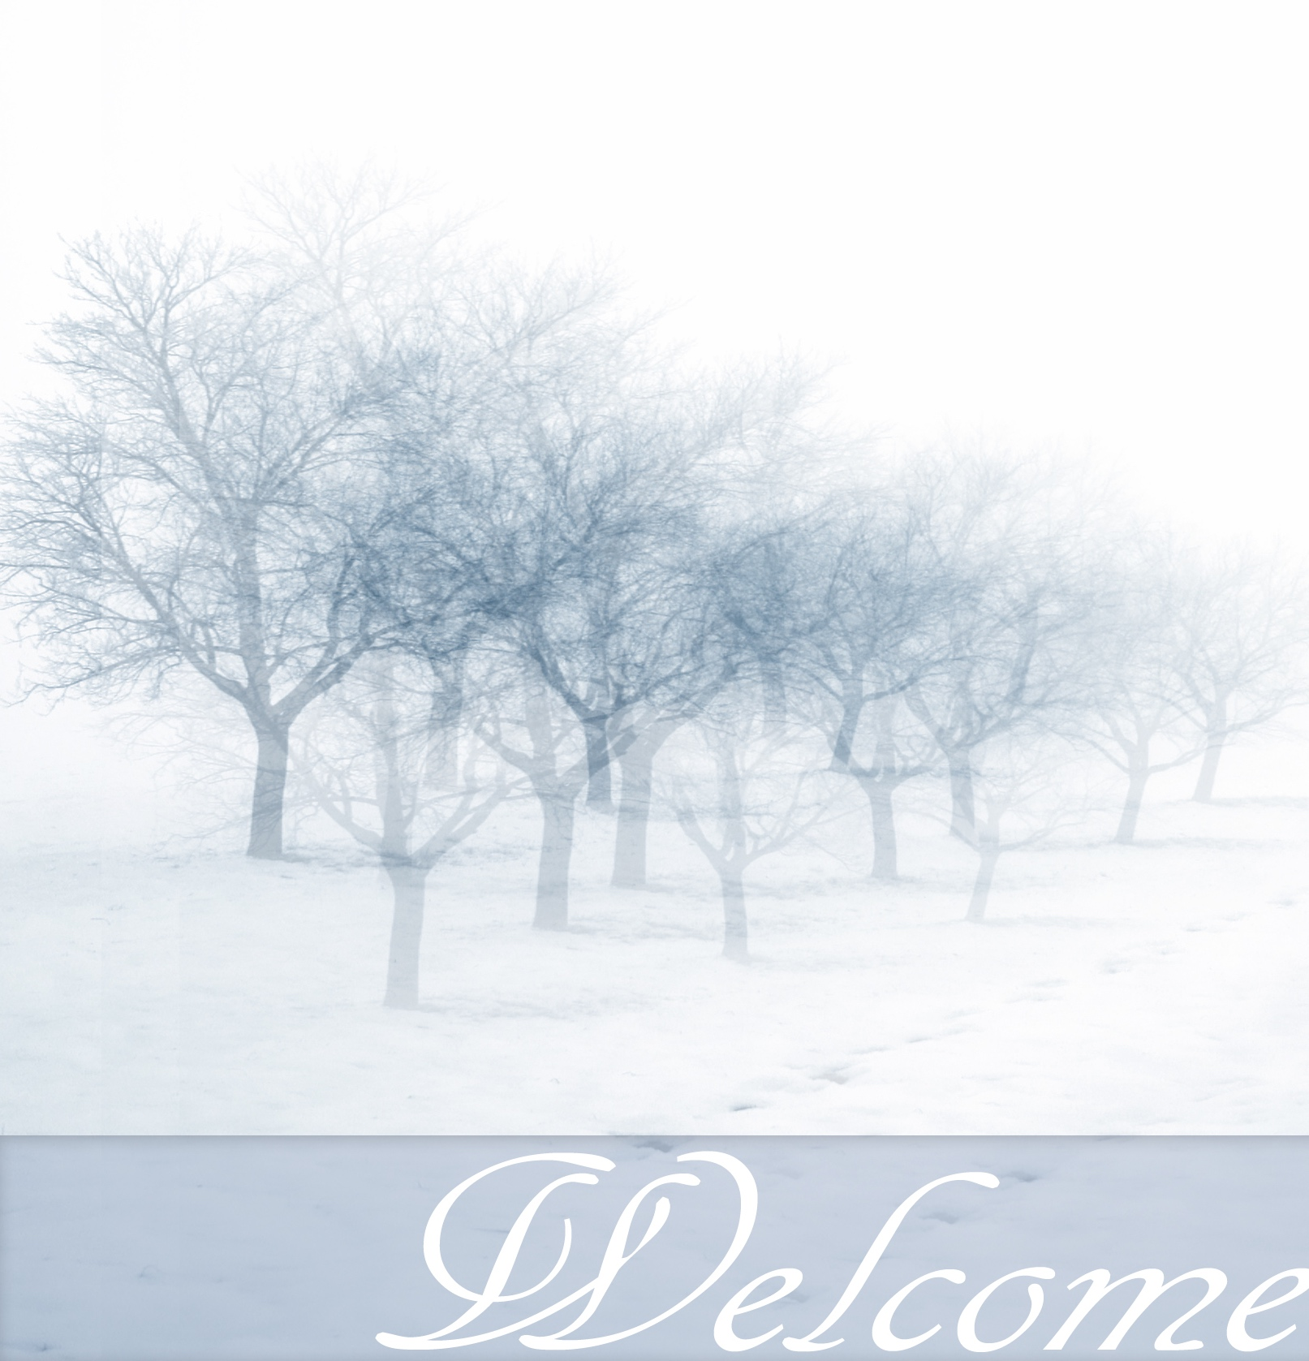

Commit your way to the LORD,
Trust also in Him,
And He shall bring it to pass.
Psalm 37:5

February 25, 2018

FELLOWSHIP BAPTIST CHURCH

Welcome To:

9:30 Adult Bible Class – the book of Genesis
TODAY’S SERVICES
February 25th, 2018

10:50-11:00 Quiet Meditation to prepare our hearts for worship
Welcome and Prayer
Call to Worship: Hebrews 1:10-14
Hymn: #3 Holy, Holy, Holy! Lord God Almighty
Hymn: #36 He Is Exalted
Hymn: 147 How Great Thou Art
Memory Verse of the Month: 2 Timothy 1:12b I am not ashamed, for I know whom I have believed and am persuaded that He is able to keep what I have committed to Him until that Day.

Announcements
Scripture Reading: 1 Chronicles 19:1-5
Hymn: In Christ Alone
Children’s Song: One Door
Children’s Story and Dismissal to Junior Church
Sermon- Pastor Rick:
“Don’t Be Rash”
Hymn: #235 Take The Name Of Jesus With You
Soup Sunday! Join us downstairs after the service for food and fellowship. All welcome.
Tonight: Power Time Prayer Chapel 6pm,
Eve. Service 6:30pm
THIS WEEK AT FELLOWSHIP:
MONDAY | 6 pm | AWANA
TUESDAY | 7:30mp | Business Meeting
WEDNESDAY | 8:30am  7:30pm | Men’s Breakfast at Trappers  Men’s Bible Study at FBC
THURSDAY | 7 pm | Music Practice
FRIDAY
SATURDAY

PRAYER
Pray for salvation for family members of our congregation. For Peter Haufe with back pain needing surgery, Alice Brandon with adrenalitis from influenza, Marie and Andy’s neighbours’ newborn son in Mount Sinai, Richard and Marie’s great-nephew who is severely ill in hospital, for Cathy’s friend Jess with cancer, for Tricia McEwen, going through personal struggles; praise for Lorena that she doesn’t have to move to Niagara. Pray for salvation for Lorena/Merv’s brother Ken with cancer. Praise for the AWANA program. If you have questions about your need for salvation from sin and hell, and what Jesus is offering you, please speak to any of the leadership and we would be happy to help you.
Pray for our Missionaries!
Thorntons –for children saved at camp & their ongoing encouragement. Lees –for Grassy Narrows people for salvation and for help re: mercury toxicity, addictions, poverty. For the 10 children that attend weekly.
Midigos –in Goma, DRC. Dangerous and violent re: upcoming elections. Having to stay inside and locals come to them for training/meetings. Government closed all communications including cell phones and internet. Financial and prayer support needed for programs. Pray for safety and for peace, and for solution for the spread of cholera in Goma and famine throughout DRC.
Butlers ––PNG, mission work, safety on the rivers. Back at work in PNG doing technical support for inland missionaries.
Brandons –coming to see us in the Spring! Cameroon Biblical Seminary – had 8 Christian leaders from 3 African countries attend for training, African professors now starting to be able to teach courses missionaries used to teach

