Vision Statement: To see a world where every person comes to know the Lord Jesus as their personal Saviour.

Mission Statement: To be a soul-winning group of believers, founded on Jesus Christ. To live as lights in our community, showing love and equipping believers for a life of serving Christ.

SERMON NOTES

_______________________________________________________________________
Please email Phebe at phebenian@gmail.com or contact Pastor Rick or one of the Deacons if you have any Prayer or Praise items or updates for the bulletin.
Pastor Rick Crockford Home: 705-746-9893
Fellowship Baptist Church
138 William Street, Parry Sound, ON, P2A 1W2
(705) 746-5154
fbc@vianet.ca www.fbcparrysound.com
FELLOWSHIP
BAPTIST CHURCH

Founded on the Rock:
Preaching the Gospel truth; Equipping for Life

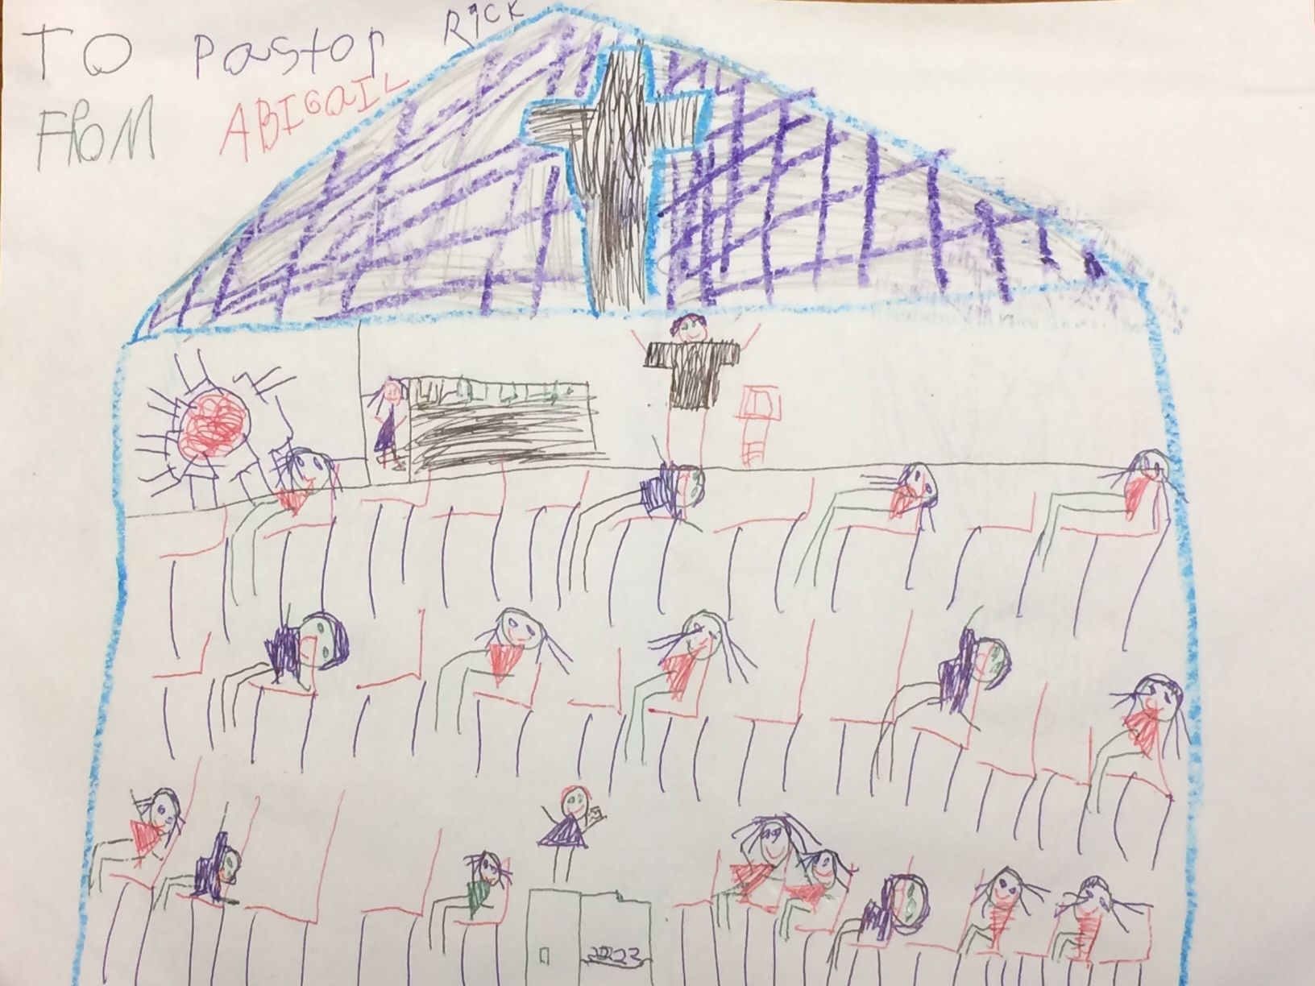
-the donation of a local artist (thanks Abigail)

Let your conduct be without covetousness;
Be content with such things as you have.
For He Himself has said,
“I will never leave you nor forsake you.”
Hebrews 13:5

Happy
new year!

January 7, 2018

FELLOWSHIP BAPTIST CHURCH

Welcome To:

9:30 Adult Bible Class – the book of Revelation
TODAY’S SERVICES
January 7, 2018

10:50-11:00 Quiet Meditation to prepare our hearts for worship
Welcome and Prayer
Call to Worship: Psalm 84:12
Hymn: #311 Hallelujah, What A Saviour
Hymn: #520 The Longer I Serve Him
Hymn: #83 There’s Something About That Name
Memory Verse of the Month: Isaiah 40:28 Have you not known? Have you not heard? The everlasting God, the Lord, The Creator of the ends of the earth, Neither faints nor is weary. His understanding is unsearchable.

Announcements
Scripture Reading: Luke 12:22-34
Video Song – Good, Good Father (Chris Tomlin)
Hymn: #45 Crown Him
Children’s Video Song: 10,000 Reasons
Children’s Story and Dismissal to Junior Church
Sermon- Pastor Rick:
“Cash In On God”
Hymn: #305 Jesus Paid It All
Communion
Hymn: #318 I Believe In A Hill Called Mount Calvary
Tonight: Power Time Prayer Chapel 6pm,
Eve. Service 6:30pm
THIS WEEK AT FELLOWSHIP:
MONDAY | 10 am  6 pm | Ladies Bible Study  AWANA
TUESDAY
WEDNESDAY | 7:30pm | Men’s Bible Study at FBC
THURSDAY | 7 pm | Music Practice
FRIDAY
SATURDAY
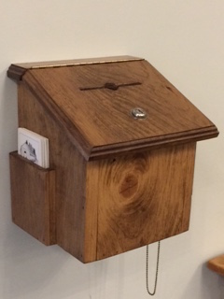
Thank you for your weekly tithes and offerings in the box at the back. “So let each one give as he purposes in his heart, not grudgingly or of necessity; for God loves a cheerful giver.”
2 Corinthians 9:7
Questions/suggestions also welcome.
PRAYER
Pray for Tricia McEwen, going through some personal struggles. Lorena re: getting through the winter then moving in May to Niagara to help her daughter, and re: her brother Ken with cancer for salvation and help.
Praise for the AWANA program! Please continue to pray for health those in our congregation, and for the salvation of any who haven’t yet accepted Jesus as their personal Saviour. If you have questions about your need for salvation from sin and hell, and what Jesus is offering you, please speak to any of the leadership and we would be happy to help you.
Pray for our Missionaries!
Thorntons –praise for children saved at camp
Lees –for Grassy Narrows people for salvation and for help re: mercury toxicity, addictions, poverty
Midigos –in Goma, DRC, need support for food and small business programs for women. Pray for safety and for peace, and for solution for the spread of cholera in Goma and famine throughout DRC.
Butlers ––PNG, mission work, safety on the rivers. Back at work in PNG doing technical support for inland missionaries.
Brandons –safety in travel, for local pastors receiving training to apply it and see spread of the gospel with locals in Cameroon and the Philippines

