Sermon Notes:

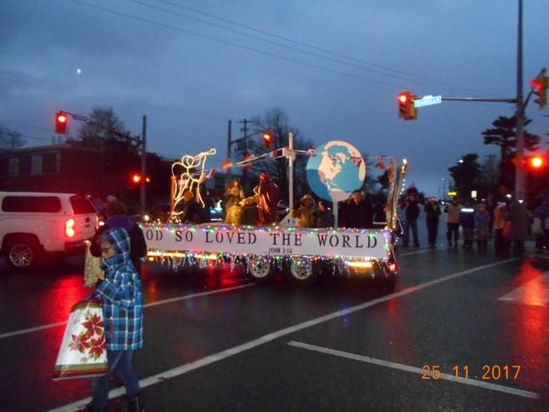

_______________________________________________________________________
Please email Phebe at phebenian@gmail.com or contact Pastor Rick or one of the Deacons if you have any Prayer or Praise items or updates for the bulletin.
Pastor Rick Crockford Home: 705-746-9893
Fellowship Baptist Church
138 William Street, Parry Sound, ON, P2A 1W2
(705) 746-5154
fbc@vianet.ca
www.fbcparrysound.com
FELLOWSHIP
BAPTIST CHURCH

Founded on the Rock:
Preaching the Gospel truth; Equipping for Life

But You, O LORD, are a shield for me,
my glory and the One who lifts up my head.
I cried to the LORD with my voice,
And He heard me from His holy hill.
Psalm 3:3,4

Welcome!
November 26, 2017

FELLOWSHIP BAPTIST CHURCH

Welcome To:

9:30 Adult Bible Class – the book of Revelation.
TODAY’S SERVICES
November 26, 2017

10:50-11:00 Quiet Meditation to prepare our hearts for worship
Welcome and Prayer
Call to Worship: 2 Samuel 22:36,37
Hymn: #626 The Lily Of The Valley
Hymn: #337 Nothing But The Blood
Hymn: #319 Near The Cross
Memory Verse of the Month: John 16:33
These things I have spoken to you, that in Me you may have peace. In the world you will have tribulation; but be of good cheer, I have overcome the world.

Announcements
Scripture Reading: Luke 12:13-21
Video Song: Overwhelmed (Big Daddy Weave)
Hymn: #11 Come, Thou Fount Of Every Blessing
Children’s Song: Lord, I Lift Your Name On High
Children’s Story and Dismissal to Junior Church
Sermon- Pastor Rick:
“Heavenly Treasure”
Hymn: #88 More Precious Than Silver
Soup Sunday! Everyone welcome downstairs after the service for a sumptuous social!
Tonight: Power Time Prayer Chapel 6pm, Eve. Service 6:30pm
THIS WEEK AT FELLOWSHIP:
MONDAY | 6:00pm | Awana
TUESDAY
WEDNESDAY | 7:30pm | Men’s Bible Study at FBC
THURSDAY | 7 pm | Music Practice
FRIDAY
SATURDAY | 4-8pm | Christmas Open House at Crockford’s
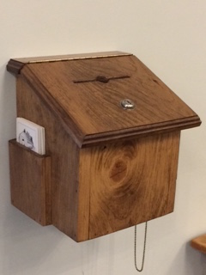
Thank you for your weekly tithes and offerings in the box at the back. “So let each one give as he purposes in his heart, not grudgingly or of necessity; for God loves a cheerful giver.”
2 Corinthians 9:7
Questions/suggestions also welcome.
Christmas Open House – Dec.2, 4-8pm at the Crockford’s
Christmas Concert-Dec.17, 11am, please let Jenny know what Christmas song, story, or skit, or reading you would like to do
New Year’s Eve – fun at the church 8pm-1am
PRAYER
Pray for Tricia McEwen, going through some personal struggles.
Thank you for praying through the week! Pray for the AWANA program. Please continue to pray for health those in our congregation, and for the salvation of any who haven’t yet accepted Jesus as their personal Savior. If you have questions about your need for salvation from sin and hell, and what Jesus is offering you, please speak to any of the leadership and we would be happy to help you.

Pray for our Missionaries!
Thorntons –praise for children saved at camp
Lees –for Grassy Narrows people for salvation and for help re: mercury toxicity, addictions, poverty
Midigos –in Goma, DRC, need support for food and small business programs for women. Pray for safety and for peace, and for solution for the spread of cholera in Goma and famine throughout DRC.
Butlers ––PNG, mission work, safety on the rivers. Back at work in PNG doing technical support for inland missionaries.
Brandons –safety in travel, for local pastors receiving training to apply it and see spread of the gospel with locals in Cameroon and the Philippines

