Sermon Notes:
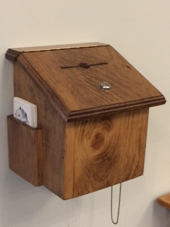
Special Note: We are currently using an offering box rather than to collect an offering. Please feel free to serve as God blesses

_______________________________________________________________________
Please email Phebe at phebenian@gmail.com or contact Pastor Rick or one of the Deacons if you have any Prayer or Praise items or updates for the bulletin.
Pastor Rick Crockford Home: 705-746-9893
Fellowship Baptist Church
138 William Street, Parry Sound, ON, P2A 1W2
(705) 746-5154
fbc@vianet.ca
www.fbcparrysound.com
FELLOWSHIP
BAPTIST CHURCH

Founded on the Rock:
Preaching the Gospel truth; Equipping for Life
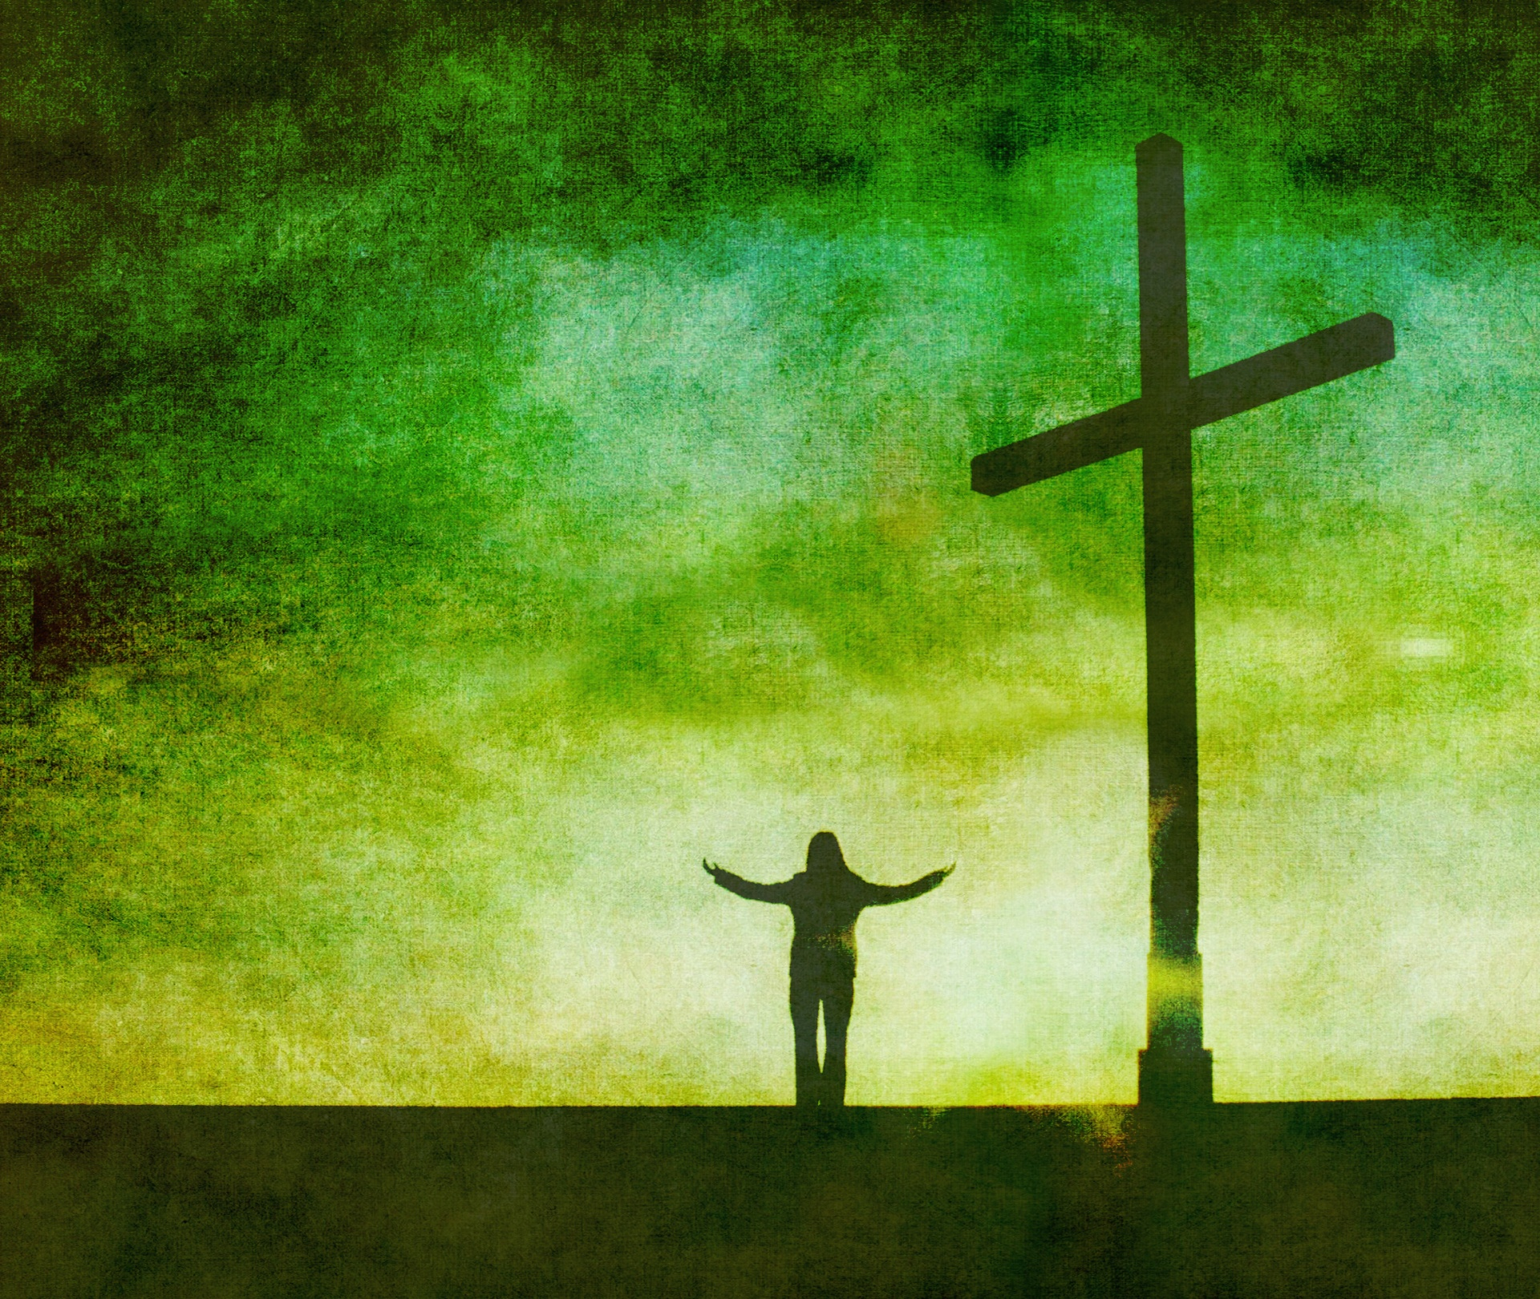

For the grace of God that brings salvation
has appeared to all men, teaching us that denying ungodliness and worldly lusts, we should live soberly, righteously, and godly in the present age.
Titus 2:11,12

Welcome!
November 19, 2017

FELLOWSHIP BAPTIST CHURCH

Welcome To:

9:30 Adult Bible Class – the book of Revelation.
TODAY’S SERVICES
November 19, 2017

10:50-11:00 Quiet Meditation to prepare our hearts for worship
Welcome and Prayer
Call to Worship: 2 Samuel 22:29-31
Hymn: #224 We Have Come Into His House
Hymn: #541 The Joy Of The Lord
Hymn: #502 In My Heart There Rings A Melody
Memory Verse of the Month: John 16:33
These things I have spoken to you, that in Me you may have peace. In the world you will have tribulation; but be of good cheer, I have overcome the world.

Announcements
Scripture Reading: Luke 12:10-12
Video
Video Song: Mighty To Save (Laura Story)
Hymn: #526 The Solid Rock
Children’s Song: #495 Jesus Loves Even Me
Children’s Story and Dismissal to Junior Church
Sermon- Pastor Rick:
“Sharing Your Soul”
Hymn: #437 Send The Light

Tonight: Power Time Prayer Chapel 6pm
Evening Service 6:30pm

THIS WEEK AT FELLOWSHIP:
MONDAY | 10am | Ladies Bible Study
TUESDAY | 7 pm | Business Meeting
WEDNESDAY | 8:30am  7:30pm | Men’s Breakfast at Trappers  Men’s Bible Study at FBC
THURSDAY | 7 pm | Music Practice
FRIDAY
SATURDAY | 10am  3:30pm | Build the float!  Meet for the parade!

Soup Sunday – next week!
Christmas Parade- This Saturday! We need your help! Come out and be sociable and have fun! Talk to Pastor Rick if you can help with construction/painting in the week ahead of time.
December 2, 4-8pm Christmas Open House at the Crockfords
December 17, 11am is our Christmas Concert, come and share a Christmas story, song or play
December 31, 8pm-1am New Year's Fun at the Church : )

PRAYER
Pray for Tricia McEwen, going through some personal struggles.
Thank you for praying through the week! Pray for the possibility of an AWANA program. Please continue to pray for health those in our congregation, and for the salvation of any who haven’t yet accepted Jesus as their personal Savior. If you have questions about your need for salvation from sin and hell, and what Jesus is offering you, please speak to any of the leadership and we would be happy to help you.

Pray for our Missionaries!
Thorntons –praise for children saved at camp
Lees –for the people of Grassy Narrows, daughter Grace –received scholarship for Masters program in the Fall, but still needs funds for the rest; praise for mission team doing VBS
Midigos –in Goma, DRC, need support for food and small business programs for women. Pray for safety and for peace, and for solution for the spread of cholera in Goma and famine throughout DRC.
Butlers ––PNG, mission work, safety on the rivers. Back at work in PNG doing technical support for inland missionaries.
Brandons –new update and prayer requests re: local pastor teaching conferences in Cameroon

