Sermon Notes:

_______________________________________________________________________
Please email Phebe at phebenian@gmail.com or contact Pastor Rick or one of the Deacons if you have any Prayer or Praise items or updates for the bulletin.
Pastor Rick Crockford Home: 705-746-9893
Fellowship Baptist Church
138 William Street, Parry Sound, ON, P2A 1W2
(705) 746-5154
fbc@vianet.ca
www.fbcparrysound.com
FELLOWSHIP
BAPTIST CHURCH

Founded on the Rock:
Preaching the Gospel truth; Equipping for Life
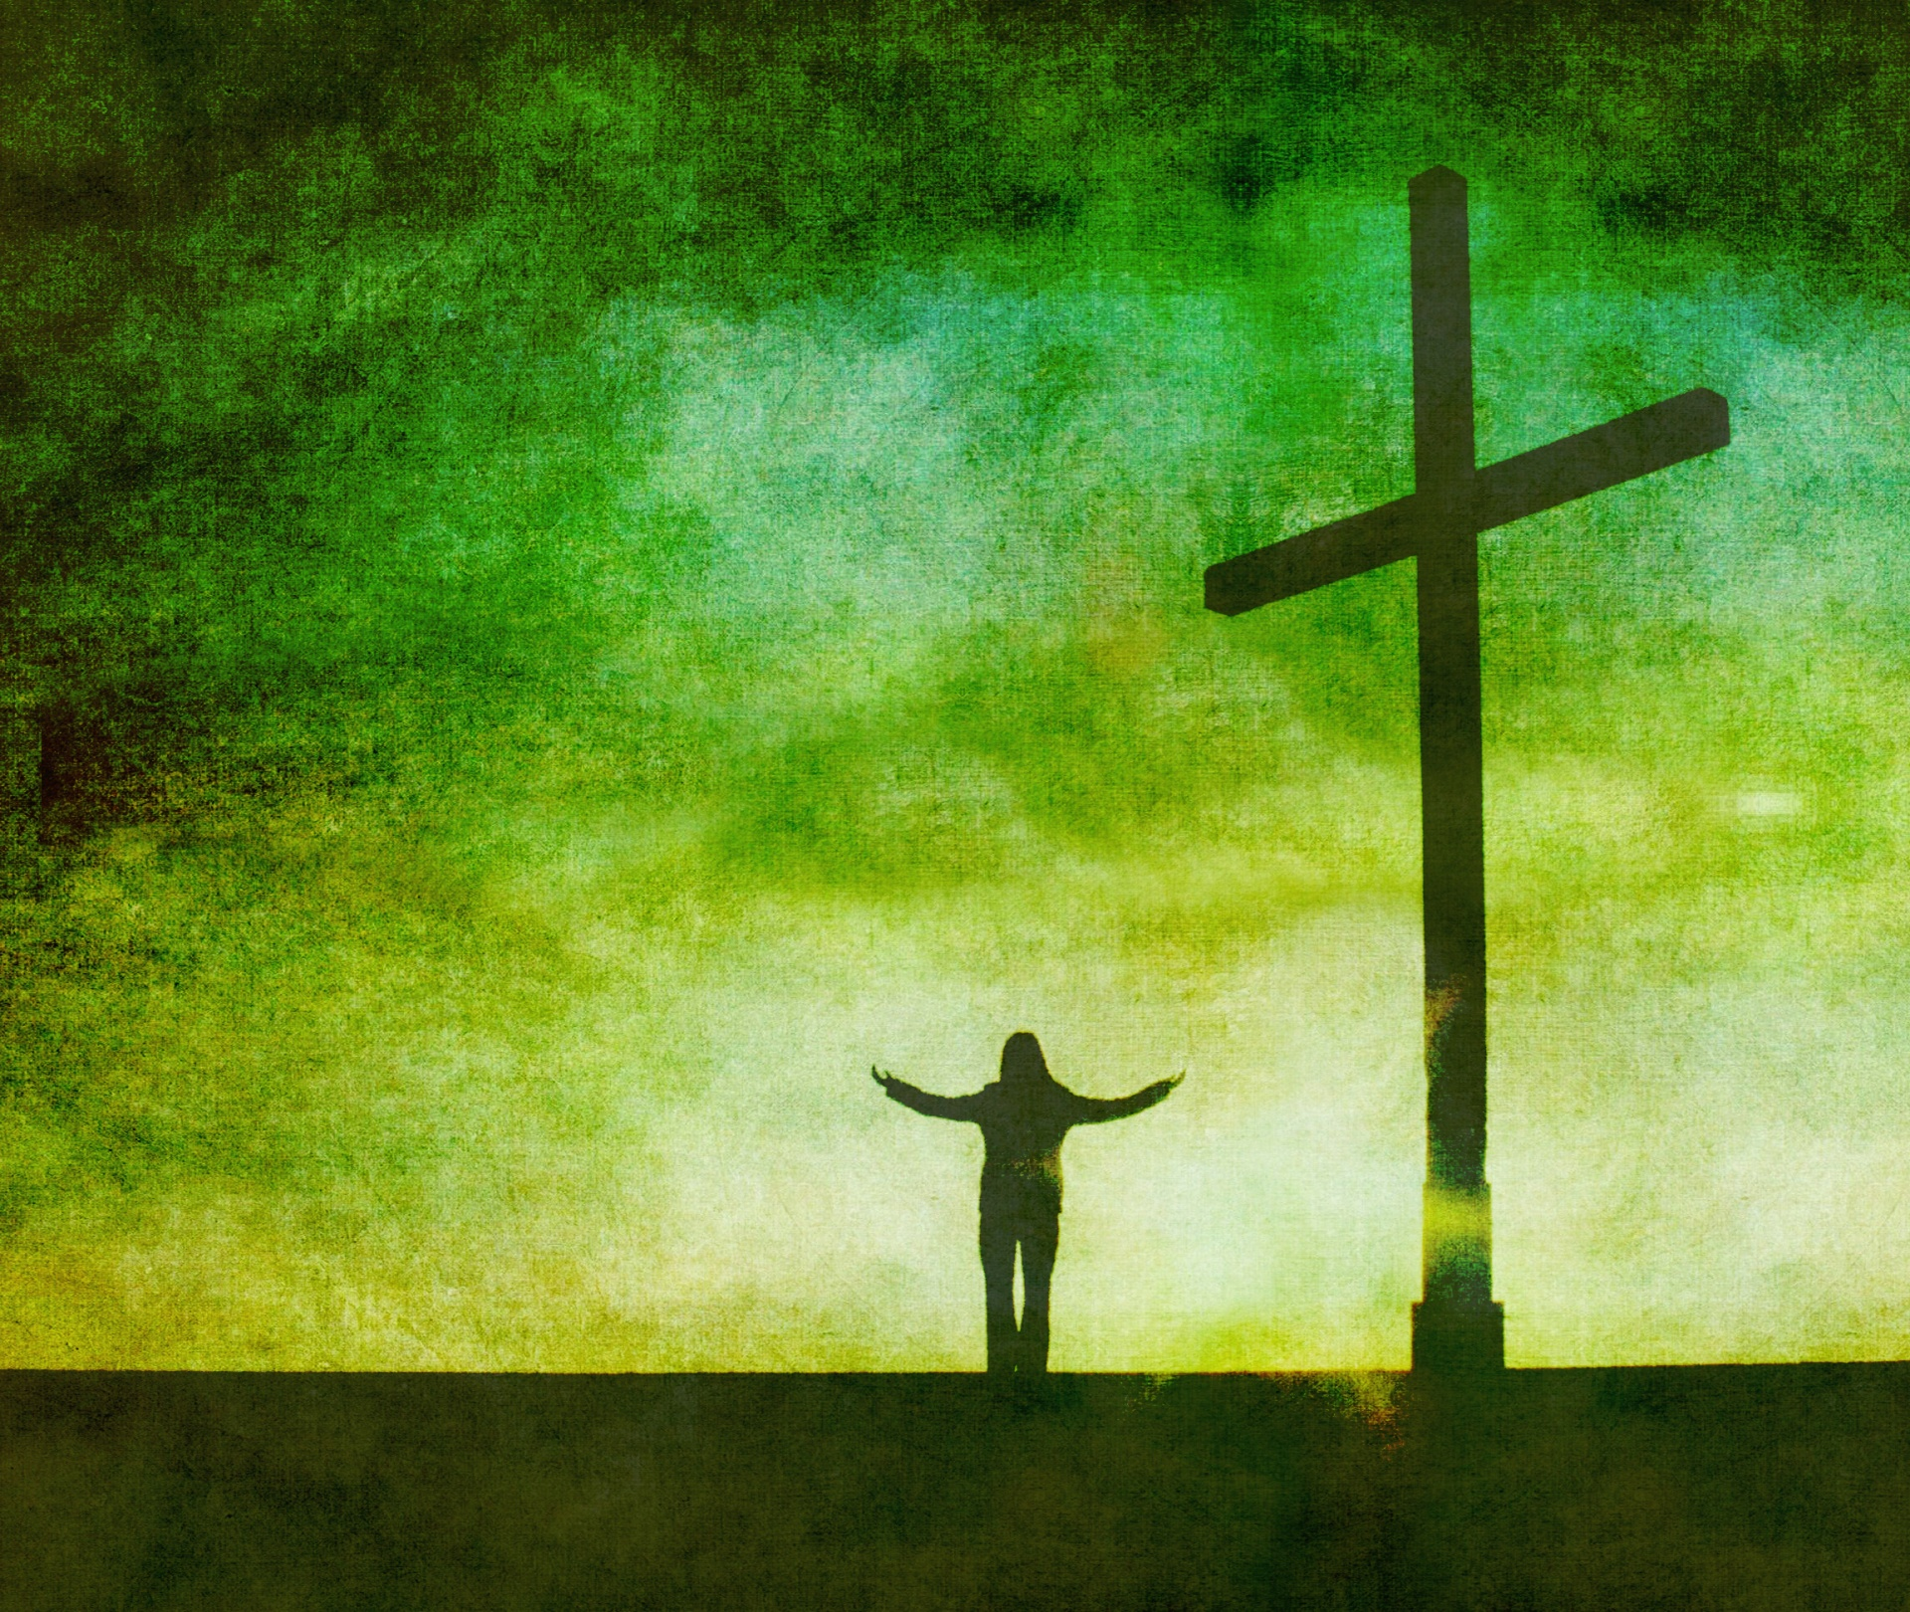

All scripture is given by inspiration of God and is profitable for doctrine, for reproof, for correction, for instruction in righteousness, that the man of God may be complete, thoroughly equipped for every good work.
2 Timothy 3:16,17

Welcome!
November 12, 2017

FELLOWSHIP BAPTIST CHURCH

Welcome To:

9:30 Adult Bible Class – the book of Revelation.
TODAY’S SERVICES
November 12, 2017

10:50-11:00 Quiet Meditation to prepare our hearts for worship
Welcome, O Canada
Moment of Silence in honour of Remembrance Day
Prayer
Call to Worship: Psalm 119:1-4
Hymn: #372 Our God Reigns
Hymn: #9 Glorify Thy Name
Memory Verse of the Month: John 16:33
These things I have spoken to you, that in Me you may have peace. In the world you will have tribulation; but be of good cheer, I have overcome the world.

Announcements
Scripture Reading: Philippians 4:14-20
Video Song: Holy Spirit (Francesca Battistelli)
Hymn: #493 Glory To His Name
Children’s Song: #374 Victory Chant
Children’s Story and Dismissal to Junior Church
Sermon- Pastor Rick:
“God’s Glory Alone”
Hymn: #56 To God Be The Glory
Tonight: Power Time Prayer Chapel 6pm
Evening Service 6:30pm

There is a short meeting immediately after church in the Adult Sunday School Room about the Christmas Float for all interested
THIS WEEK AT FELLOWSHIP:
MONDAY
TUESDAY
WEDNESDAY | 7:30pm | Men’s Bible Study at FBC
THURSDAY | 7 pm | Music Practice
FRIDAY | 6pm | Training for Awana Leaders
SATURDAY

Business Meeting – November 21, 7pm
Christmas Parade- November 25- please pitch in and help in the morning, and join us for a ride or walk in the parade in the afternoon. Talk to Pastor Rick if you can help ahead of time.
December 2, 4-8pm Christmas open house at the Crockfords
December 31, 8-1pm New Year's celebration and Games night at the church : )
PRAYER
Pray for Tricia McEwen, going through some personal struggles.
Thank you for praying through the week! Pray for the possibility of an AWANA program. Please continue to pray for health those in our congregation, and for the salvation of any who haven’t yet accepted Jesus as their personal Savior. If you have questions about your need for salvation from sin and hell, and what Jesus is offering you, please speak to any of the leadership and we would be happy to help you.

Pray for our Missionaries!
Thorntons –praise for children saved at camp
Lees –for the people of Grassy Narrows, daughter Grace –received scholarship for Masters program in the Fall, but still needs funds for the rest; praise for mission team doing VBS
Midigos –in Goma, DRC, need support for food and small business programs for women. Pray for safety and for peace, and for solution for the spread of cholera in Goma and famine throughout DRC.
Butlers ––PNG, mission work, safety on the rivers. Back at work in PNG doing technical support for inland missionaries.
Brandons –new update and prayer requests re: local pastor teaching conferences in Cameroon

-Please note that Pastor Rick will be at the Fellowship National Convention in Toronto This week on Monday-Wednesday night late

